**Screenshot of the SparkPi output :**

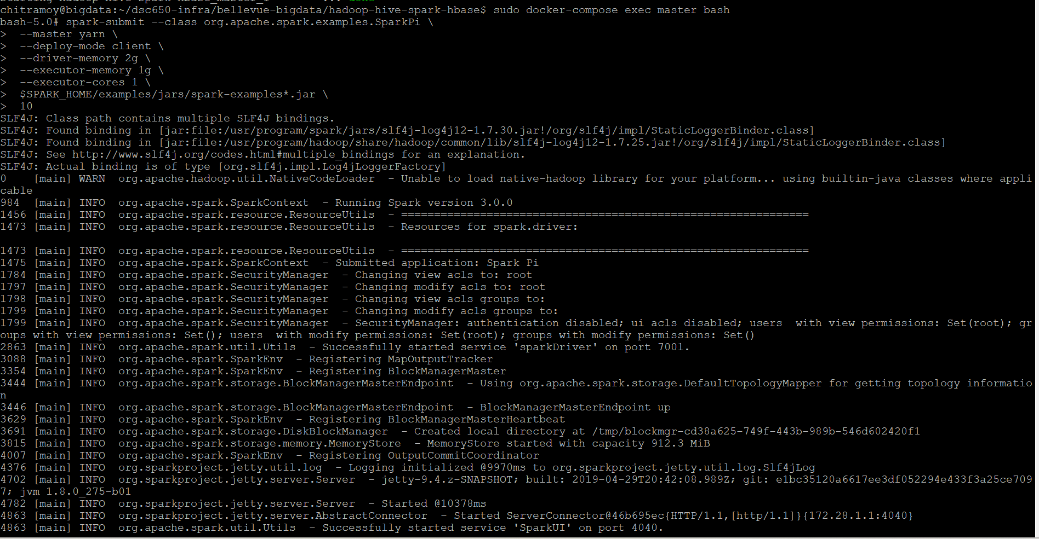

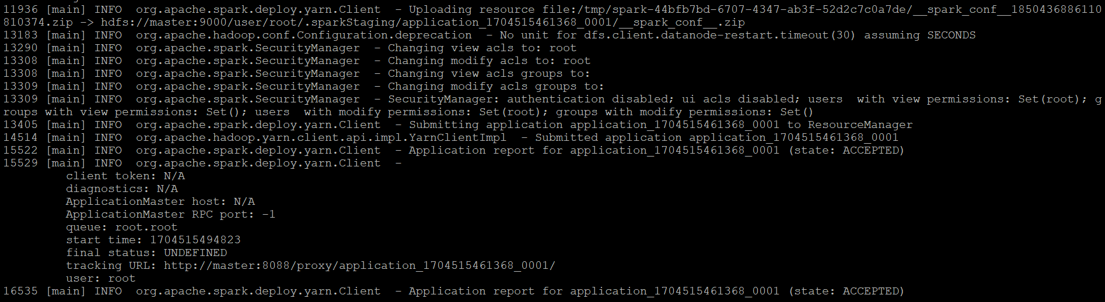

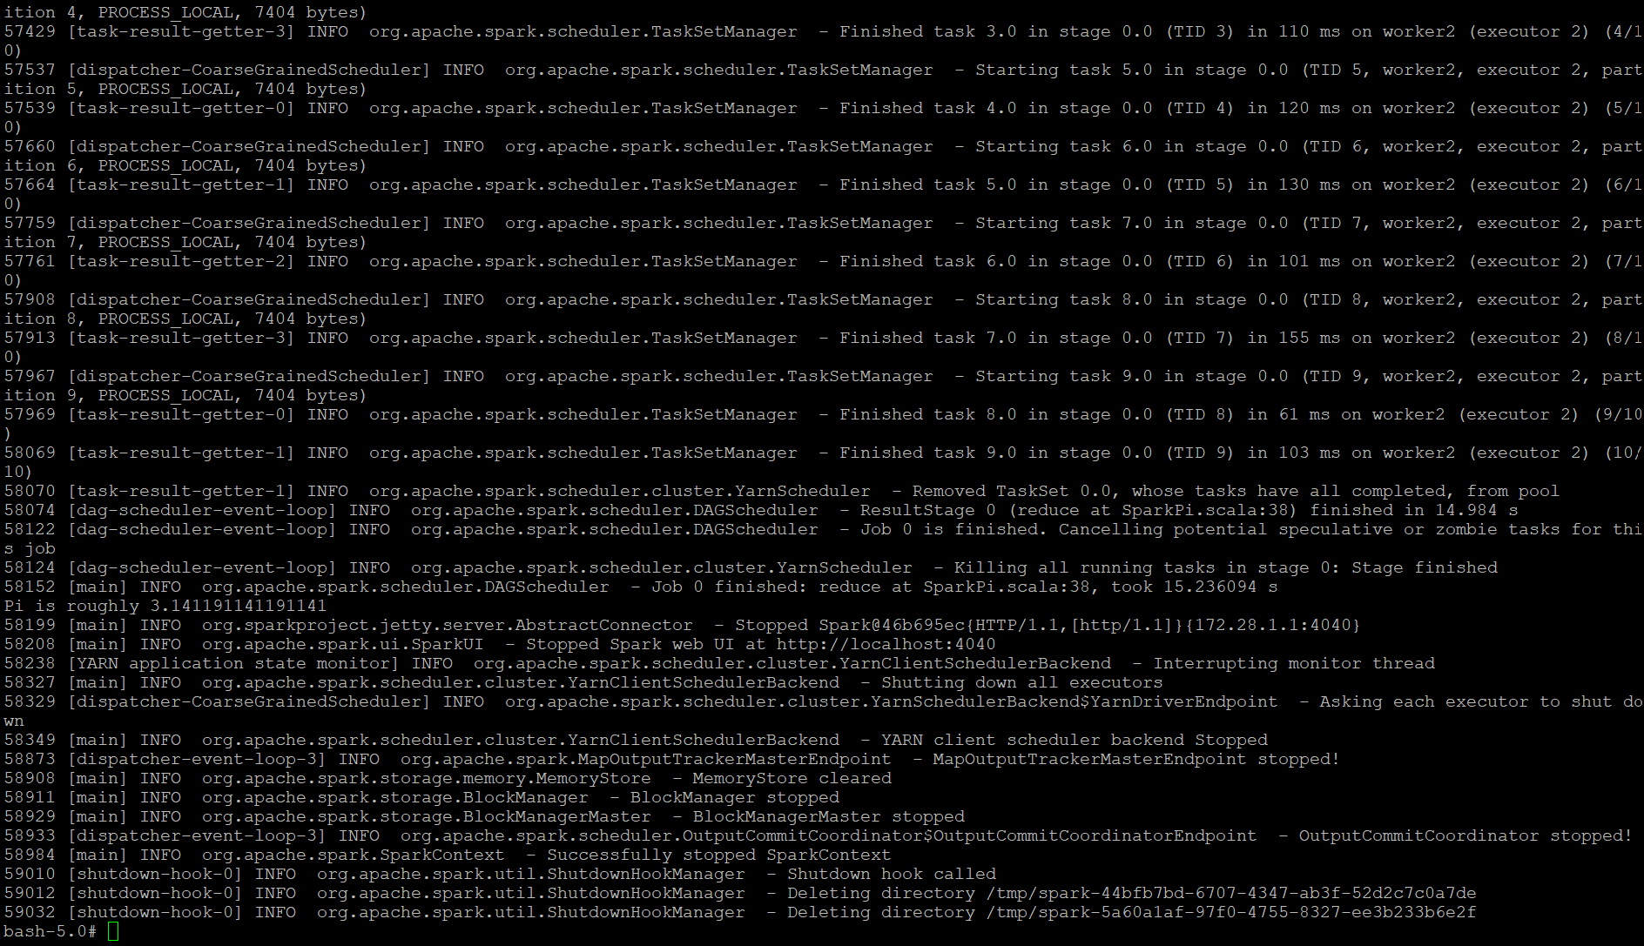

**Screenshot of the first 100 generated random numbers :**

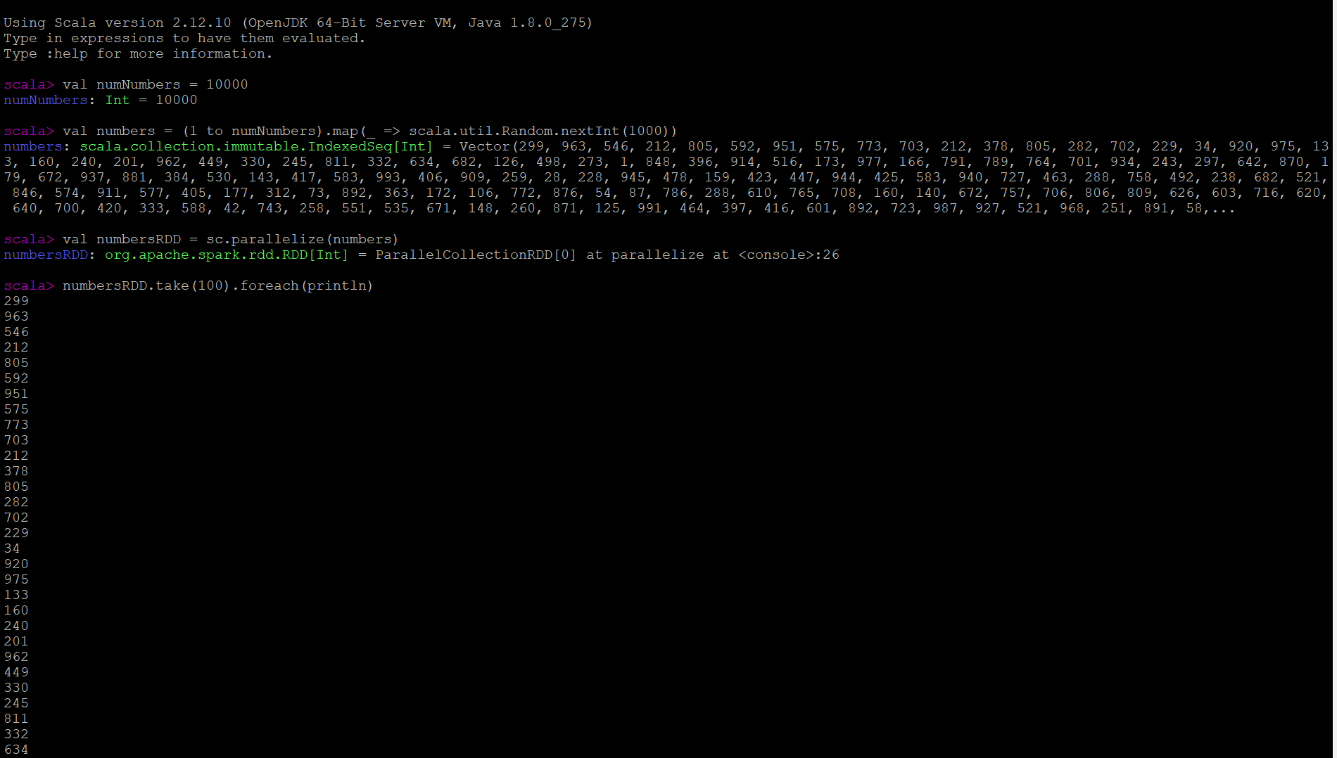

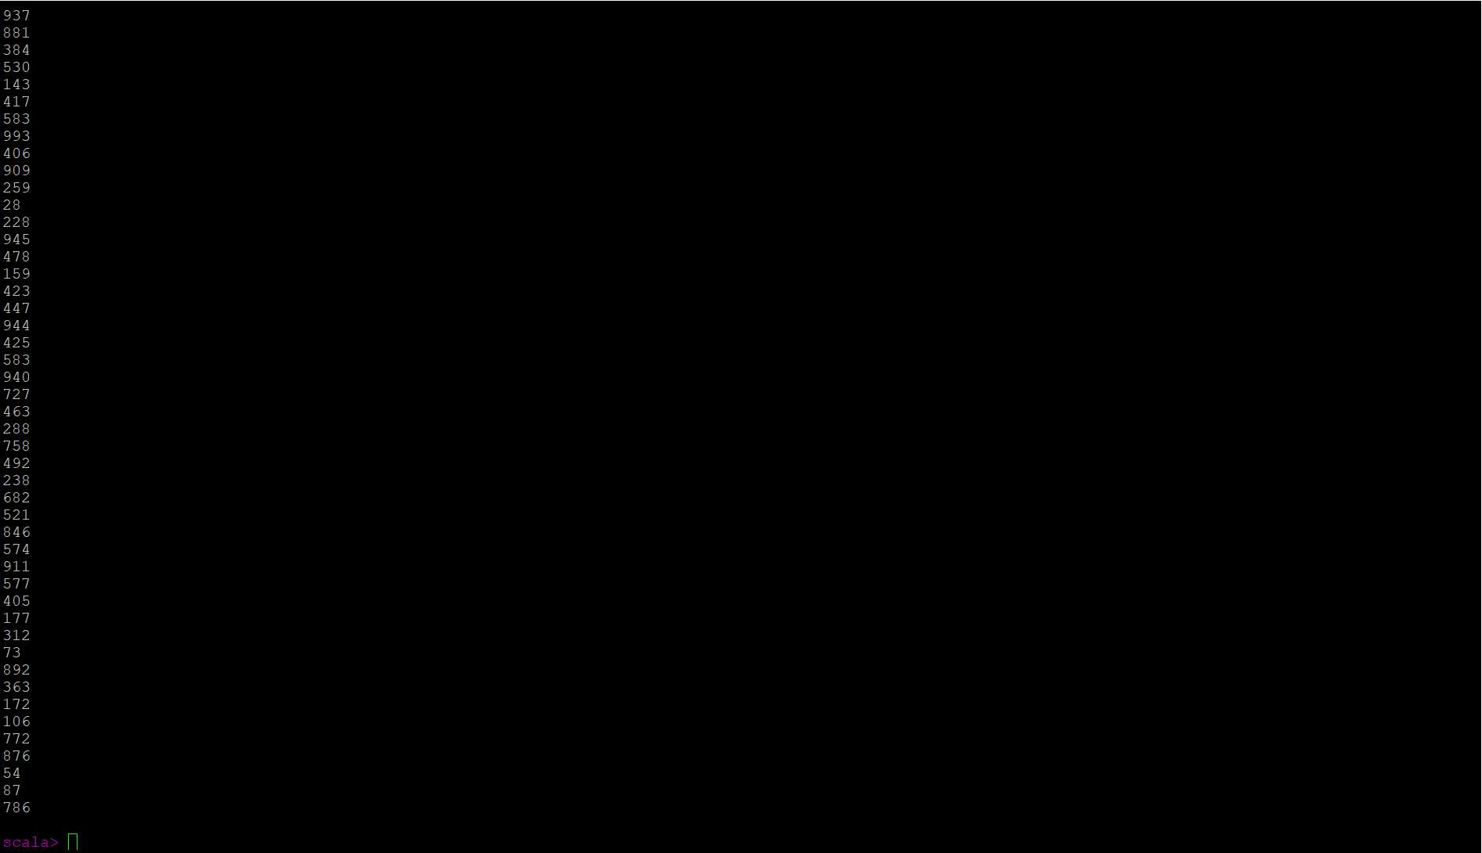

**Screenshot of a segment of the generated transformed sentences and an explanation of your unique transformation :**

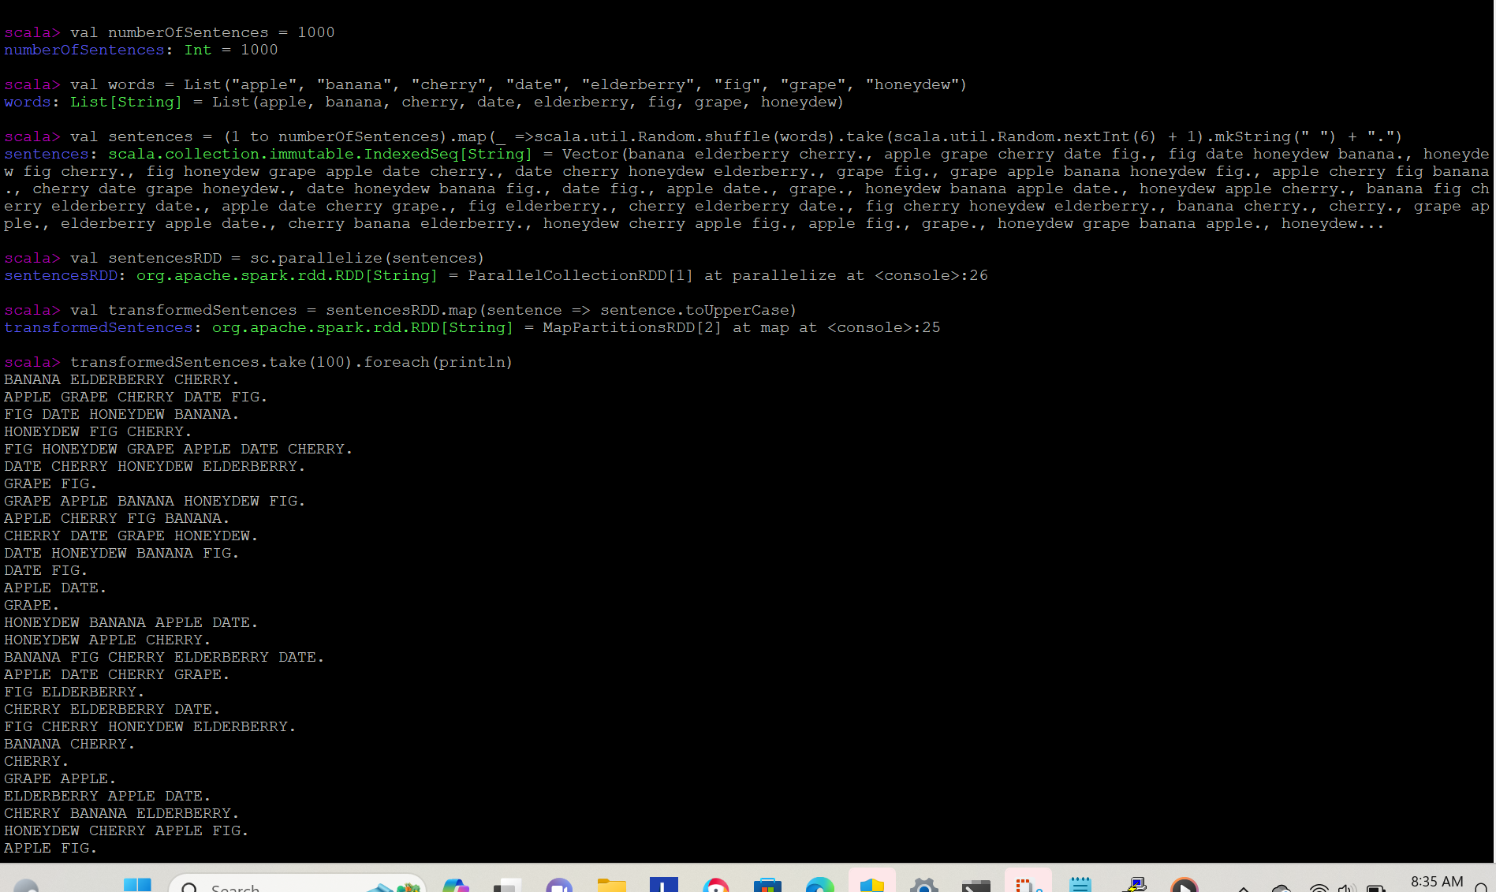

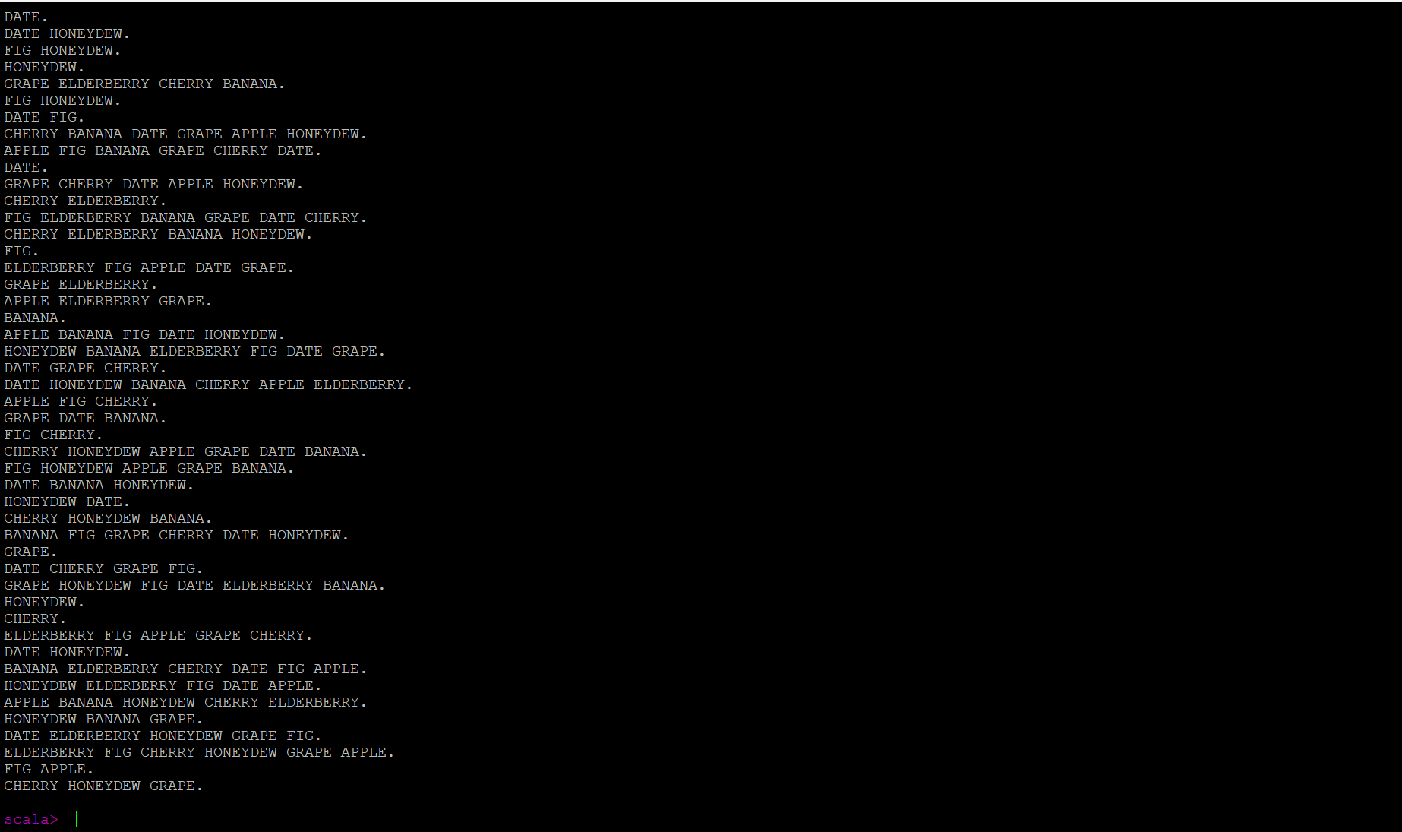

Used toUpperCase transformation code to convert the all the sentences with Uppercase letters. The program uses numberOfSentences which basically specifies the total number of sentences to be generated. Words defines a list of words that can be used to build the sentences. Then it defines how the sentences will be formed using random words from the list and sentences will be generated from one to numberOfSentences. sc.parallelize(sentences): Converts the list of sentences into an RDD. sc is assumed to be the SparkContext.